**Institution**

**Student name**

**Course**

**4.3**

$$Using the Equal loudness contours$$

$20dB IL at 100 = 20 phones$

$$20dB at 500Hz 20 phones$$

$$∴ the two tones are equal$$

$40dB IL at 200hz = 20-30 phones$

$$30dB IL at 200Hz = 40phones$$

$$∴30bD IL at 200hz is louder by 10phones$$

$50dB IL at 100Hz = 20-30phones$

$$50dB IL at 1000Hz = 50phones$$

$$∴50dB IL at 1000Hz is louder by appx 20phones$$

**5.11**

$$Given x[n] = a|n|$$

$$x\left[n\right]=a^{n}=a^{n}+a^{-n}u\left(-n-1\right)$$

$$z\left\{a^{n}\right\}=z\left\{a^{n}u\left[n\right]\right\}+a^{-n}u[-n-1]$$

$$Since u[n] =1$$

$$z\left\{a^{n}u\left[n\right]\right\}=\sum_{n=-∞}^{∞}{x\left[n\right]z^{-n}=\sum_{n=0}^{∞}{{\left(az^{-1}\right)}^{n}}}$$

$$=\frac{1}{1-az^{-1}}=\frac{z}{z-a}$$

Therefore

$$\frac{1}{\sum_{n=0}^{∞}{a^{n}z^{-n}}}=1-az^{1}$$

**5.12**

|  |  |
| --- | --- |
|  |  |

**b)**

$$Vk(z) =\frac{1 - 2\left|zk\right|cos θk + {\left|zk\right|}^{2}}{1 - 2\left|zk\right|cos θkz-1 + \left|zk\right|2z^{-2}}$$

$$X\left(z\right)H\left(z\right)=Y(z)$$

$$X\left(z\right)\frac{1 - 2\left|zk\right|cos θk + {\left|zk\right|}^{2}}{1 - 2\left|zk\right|cos θkz-1 + \left|zk\right|2z^{-2}}=Y(z)$$

$X\left(z\right)- X\left(z\right)2\left|zk\right|cos θk + X\left(z\right)\left|zk\right|2+ Y\left(z\right)2\left|zk\right|cos θkz^{-1}+Y\left(z\right)\left|zk\right|2z^{-2}=Y(z)$,

Converts to

$$x\left[n\right]-x\left[n\right]2\left|zk\right|cos θk + x\left[n\right]\left|zk\right|2+ y[n-1]2\left|zk\right|cos θk+\left|zk\right|2y[n-2]=y[n]$$

**c)**

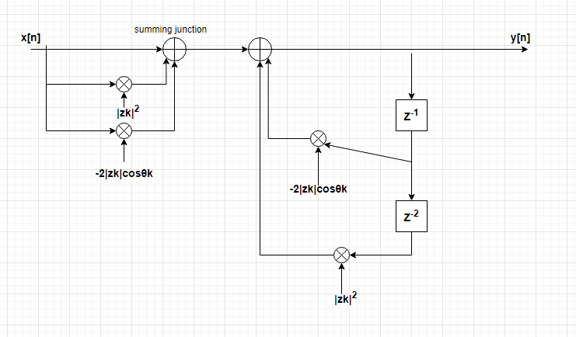

**5.17.**

Check MATLAB code provided